PROJECT REPORT BY GROUP B

**FORECASTING THE TRANSITION: ANALYSING THE FEASIBILITY FOR RENEWABLE ENERGY ADOPTION IN NSW**

Kiara Zentrich (z5382804)

Mathew Fraser(z5433663)

Santosh Ban (z5441817)

Karunya Sankar Kumar (z5339860)

March 2024

SUBMITTED IN FULFILMENT OF THE REQUIREMENTS OF THE CAPSTONE COURSE ZZSC9020

Plagiarism statement

I declare that this thesis is my own work, except where acknowledged, and has not been submitted for academic credit elsewhere.

I acknowledge that the assessor of this thesis may, for the purpose of assessing it:

* Reproduce it and provide a copy to another member of the University; and/or,
* Communicate a copy of it to a plagiarism checking service (which may then retain a copy of it on its database for the future plagiarism checking).

I certify that I have read and understood the University Rules in respect of Student Academic Misconduct and am aware of any potential plagiarism penalties which may apply.

By signing this declaration, I am agreeing to the statements and conditions above.

Signed: ___________________________________________ Date: ________________________

Signed: ___________________________________________ Date: ________________________

Signed: ___________________________________________ Date: ________________________

Signed: ___________________________________________ Date: ________________________

Acknowledgements

By far the greatest thanks must go to our supervisor for the guidance, care and support they provided.

20/04/2024

# Abstract

Electricity serves as a cornerstone of modern civilisation, powering industries, homes, and critical infrastructure. However, the reliance on non-renewable sources of electricity generation poses significant environmental challenges, exacerbating climate change and endangering ecosystems. In response, the transition to renewable energy sources has emerged as a pressing priority worldwide. This project addresses the transition to a fully renewable energy-based electricity supply in New South Wales (NSW), Australia. The Ecological Defenders Office (EDO), a prominent environmental advocacy firm in NSW, seeks evidence-based forecasts to assess the feasibility of achieving this transition within the next decade. Specifically, the project aims to determine when renewable energy generation can meet forecasted electricity demand in the region. The significance of this endeavour cannot be overstated. Transitioning to renewable energy not only mitigates environmental harm but also fosters energy independence and resilience. The methodology for this project involves several key steps. Firstly, historical electricity demand data will undergo preprocessing to clean, detect outliers, and impute missing values. External factors such as weather data will be incorporated to enhance forecasting accuracy. Exploratory data analysis will identify relevant features, trends, and seasonal patterns. Supervised machine learning models, particularly regression and classification, will be employed for forecasting, considering the non-linear nature of the data. The project will utilise Python programming language and libraries such as scikit-learn and matplotlib for implementation. Google Colab will provide a collaborative development environment, ensuring reproducibility and transparency. Lastly, the data used for analysis will comprise historical electricity demand data, weather data, and additional external factors. This data, while comprehensive, may require normalisation and transformation to facilitate accurate modelling. By employing a combination of statistical and machine learning techniques, this project aims to deliver actionable insights into the feasibility of transitioning to renewable energy in NSW. The findings will inform advocacy efforts and policy decisions, driving progress towards a sustainable energy future. By providing the EDO with accurate forecasts, this project empowers them to advocate for policies and investments that accelerate the transition to renewable energy in NSW.

# Contents

Abstract 4

Contents 5

1 Introduction 6

2 Literature Review 8

3 Material and Methods 10

3.1 Software 10

3.2 Description of the Data 11

3.3 Pre-Processing Steps 14

3.4 Data Cleaning 14

3.5 Assumptions 14

3.6 Modelling Methods 14

4. Exploratory Data Analysis 17

5. Analysis and Results 21

6. Discussion 23

7. Conclusion and Further Issues 23

References 23

Appendix 24

Activities and Schedule 24

Team Skill Mapping 24

Individual Skill Mappings 26

# 1 Introduction

Electricity is a versatile and widely used source of power that has transformed industries, communication, and daily life, contributing to global progress, and shaping the way we live and work. Produced through various means, including fossil fuels, nuclear reactions, and renewable sources, electricity is transmitted through power grids to homes, businesses, and industries.

However, it is now globally recognised that non-renewable sources of electricity generation, particularly fossil fuels (namely coal, natural gas, and oil) have significant and sustained deleterious effects on the environment [1]

Continued use of these sources would further exacerbate climate change, jeopardising ecosystems, threatening the survival of species, and undermining the health and well-being of present and future generations [2]. As a result, renewable sources, such as wind, solar and hydro, have emerged as clean alternatives to generate electricity whilst reducing dependency on fossil fuels and greenhouse gas emissions.

Transforming the electricity network into a 100% renewable energy scenario is a crucial, but challenging priority in New South Wales (NSW). Achieving this target as soon as possible will result in a greater reduction of potential climate impacts within the region. However, a key concern is whether renewable sources can reliably provide enough electricity to meet NSW demand. The aim of this project is to provide a key environmental advocacy firm in NSW, The Ecological Defenders Office, with evidence-based forecasts to answer the following question: **Is the transition to a fully renewable energy-based electricity supply achievable within NSW in the next 10 years?**

The output from this analysis and modelling will empower the Ecological Defenders Office (EDO) to make informed advocacy and funding decisions. NSW currently has close to 13,500 megawatts of renewable energy generation capacity, which is 53% of total generation capacity in the state [3]. The EDO recognise this as strong progress, however achieving a fully clean energy state remains way off, with the current capacity representing just over halfway toward that goal. The EDO has commissioned this work to understand the earliest point in time at which achieving a 100% renewable electricity target is feasible. By determining this timeline, they aim to devise effective lobbying strategies for governments and electricity providers. If forecasts indicate that renewables can meet demand earlier in the 10-year period, the organisation can prioritize shorter-term, high-intensity campaigns. However, if the forecasts suggest feasibility closer to the 10-year mark, longer-term advocacy requiring extensive planning and organisation will be necessary [4]

This project aims to assess the viability of transitioning to a fully renewable electricity supply in NSW within a decade. Feasibility will be determined based on the analysis indicating whether electricity supply from renewable sources can meet predicted demand levels. The project methodology involves the use of data science techniques to (1) forecast electricity demand in NSW for the next decade and then (2) forecast the supply of electricity solely from renewable sources in NSW over the same period. These forecasts can be generated using two multivariate regressions with the target variables as electricity demand and renewable electricity supply respectively. Finally, the project will then integrate the results from these models to determine the point at which supply can effectively match demand.

# 2 Literature Review

There are many different approaches to forecasting electricity demand. The choice of approach depends on factors such as the availability of data, the forecasting horizon, the level of detail required, and the specific characteristics of the electricity system being modelled. In this paper, the scope is mainly influenced by the forecasting horizon. We want to forecast 10 years ahead from now therefore, that puts a constraint on the model choices we have.

[5] presents a simple and easy-to-understand method for the next decade of energy demand forecasting based on a nonlinear autoregressive (NAR) neural network. From its time series past values, NAR structurally is an optimal predictor for a future variable. This is useful as the we have the NSW demand data from 2016 and that could be used on its own to predict the future demand without depending on any other variables.

[6] introduces a comprehensive Long Short-Term Memory (LSTM) based model for forecasting electricity demand and price in large datasets within smart city contexts. The model operates as a sequence-to-sequence network, utilizing real electricity market data sourced from the Australian Energy Market Operator (AEMO) for validation. Through various simulations on actual data with different configurations, the model demonstrates its capability to generate reliable predictions. Validation results indicate that the proposed model outperforms existing methods, including Support Vector Machine (SVM), Regression Tree (RT), and Neural Nonlinear Autoregressive network with Exogenous variables (NARX), in terms of Root Mean Square Error (RMSE) and Mean Absolute Error (MAE). Specifically, the proposed model shows improvements of 11.25%, 20%, and 33.5% in RMSE, and 14%, 22.5%, and 32.5% in MAE compared to SVM, RT, and NARX respectively, particularly in forecasting electricity demand. Furthermore, the proposed model demonstrates its ability to provide reliable forecasts even without extensive historical datasets.

In this project, we are dealing with a time series dataset as opposed to a static dataset. Time series is a special type of data set in which one or more variables are measured over time. There are numerous models for time series forecasting. The three main categories are Classical time series models (ARIMA family), Supervised models (Linear Regression, Random Forest and XGBoost), and Deep learning-based models (LSTM, Prophet, DeepAR). [7]

Linear regression serves as a solid baseline model choice, while random forest, XGBoost, and support vector machines (SVMs) excel in managing non-linear relationships and intricate data structures. While classical machine learning (ML) models can be employed for forecasting, they may fall short compared to specialized time-series forecasting techniques like autoregressive models, moving averages, and recurrent neural networks (RNNs). The primary reason for this discrepancy lies in classical ML models' assumption of independent and uniformly distributed data points, a feature often absent in time series data. Time series data is characterized by temporal dependencies, where values at one time point are influenced by those at preceding points. The independence assumption challenges classical ML models' ability to discern underlying patterns and trends. Additionally, classical ML models are ill-equipped to handle time-varying features or unevenly spaced time series data, common occurrences in forecasting tasks. For instance, classical ML models may struggle to capture long-term seasonality trends within the data [8].

There are multiple dependent variables such as Temperature, Population, Climate Change, Impact of AI, Technology, and other potential macroeconomic variables that could influence electricity demand a decade from now. An explanatory model proves advantageous as it integrates information from various variables, rather than solely relying on past values of the variable under consideration (Demand). Nonetheless, there are several reasons why a forecaster might opt for a time series model over an explanatory or hybrid model. Firstly, the system may lack full understanding, and even if it were comprehensible, measuring the assumed relationships governing its behavior might prove exceedingly challenging. Secondly, forecasting the future values of the multiple predictors necessary to forecast the variable of interest might present significant difficulty. Thirdly, the primary objective may solely be predicting future outcomes without delving into the reasons behind them. Lastly, a time series model devoid of explanatory variables may yield more accurate forecasts compared to an explanatory or hybrid model. [9]

Due to time constraints of this project, the forecast for electricity produced by renewable energy in the next decade is obtained from previous work instead of forecasting it by ourselves. Climate Energy Finance’s NSW Electricity model leverages the Open NEM database and models their estimates of Electricity Demand and Supply which includes Total Renewable Energy Generation (Annual in TWh). The full table is provided in Table 1 below [10]. To obtain the Total RE Generation for the 3 remaining years, i.e. 2031, 2032 and 2033 a simple Straight Line Forecast through all the available points using Least Squares method was used. The coefficients found for y = ax + b were a = 2.469, b = -6.714. The forecasted RE Generation for 2031 = 45 TWh, 2032 = 48 TWh, 2033 = 50 TWh.

*50TW = 5x1e7 MW Annually*

*Convert annual value to daily value: 5x1e7 / 365 days * 24 hours = 5708 MW (approx.)*

*In 2033, Estimated RE Generation per hour is 5708MW. From our results, the predicted hourly electricity demand is 5885 MW in 2033 (without Rooftop PV).*

*9121 MW is the total predicted demand including Rooftop and other RE sources.*

Table 1 CEF’s NSW Electricity Model of Demand and Supply (Annually, TWh)

# 3 Material and Methods

## 3.1 Software

**Software:**

This section outlines the software tools, libraries, and platforms that will be used for implementing the electricity demand forecasting methodology. It emphasizes the use of open-source software, reproducibility, and accessibility to promote transparency and collaboration.

**Development Environment:** The paper will be implemented using Python programming language, leveraging its rich ecosystem of libraries for data analysis, machine learning and timeseries forecasting.

**Libraries:** The following libraries will be implemented in the code developed for this project

* Pandas and NumPy will be used to manipulate the data and perform any necessary operations to examine or transform the data.
* Scikit-Learn will be used to generate the regression models that will be employed for the forecasting methods.
* The Matplotlib and Seaborn libraries will be used to create any visualisations needed for data analysis or for the explanation and discussion of results.

**Integration and Workflow:** A Jupyter notebook hosted in Google Colab will be used to develop and execute the code. Colab has been chosen as it is cloud based which allows for ease of access to all team members, as well as providing GPU and TPU resources which will allow complex models to be run more efficiently than on any of the team’s local resources. Colab will also enable easy version control as it can be connected to the GitHub repository being used by the team.

## 3.2 Description of the Data

**Data Description**

At this stage of the project, five datasets have been selected for use in the analysis and modelling involved in this forecasting electricity demand research. The details and relevance of each are below:

|  |  |
| --- | --- |
| Dataset: **Total Electricity Demand (NSW)** | |
| Source | Market Management System database, National Energy Market |
| Format | CSV |
| Storage | 5.8MB |
| Variables | DATETIME: Date and time interval of each observation in the format (dd/mm/yyyy hh:mm). In 5 minute increments.  TOTALDEMAND: Total demand (MW)  REGIONID: Region Identifier (i.e. NSW1) |
| Messiness | NA: 0  Duplicates: 0  Inconsistencies:   * Format of DATETIME is object. In cleaning, should change to a consistent datetime data type for easier manipulation. |
| Size | 196513 rows x 3 columns |
| Relevance | This data shows historical electricity demand in NSW from 2010-01-01 to 2021-03-18. Historical demand is a powerful feature, which can be used as a predictor variable in electricity forecasting models. |

|  |  |
| --- | --- |
| Dataset: **Air Temperature (NSW)** | |
| Source | Australian Data Archive for Meteorology |
| Format | CSV |
| Storage | 6.9MB |
| Variables | DATETIME: Date time interval of each observation (dd/mm/yyyy hh:mm)  TEMPERATURE: Air temperature (°C)  LOCATION: Location of a weather station (i.e. Bankstown weather station) |
| Messiness | NA: 0  Duplicates: 13 duplicated rows  Inconsistencies:   * Format of DATETIME is object. In cleaning, should change to a consistent datetime data type for easier manipulation. * The smallest gap between temperature observations is 1 minute and the largest gap is 3 days, 18hrs and 30mins. |
| Size | 220326 rows x 3 columns |
| Relevance | Air temperature data covering 2010-01-01 to 2021-03-18 can also be considered as a potential predictor variable in forecasting. This data will be examined more deeply in the exploratory data analysis stage to identify if there is indeed a correlation between temperature and electricity usage. If this is proven, the data will form part of the modelling work undertaken in this project. |

|  |  |
| --- | --- |
| Dataset: **Population and Projected Population Totals (persons), 1971-2061** | |
| Source | 2022 NSW Common Planning Assumption Projections, NSW Government |
| Format | XLSX |
| Storage | 1.4MB |
| Variables | YEAR: The calendar year for each population projection (yyyy)  POPULATION: Number of total persons living in NSW in a given year |
| Messiness | NA: 0  Duplicates: 0  Inconsistencies: 0 |
| Size | 91 rows x 2 columns |
| Relevance | This data covers NSW population from 1971 to 2023, and then projected population to 2061. This data will be examined more deeply in the exploratory data analysis stage to identify if there is a relationship between population and electricity demand. If this is proven, the data will form part of the modelling work undertaken in this project. |

|  |  |
| --- | --- |
| Dataset: **Forecasted Demand (NSW)** | |
| Source | Market Management System database, National Energy Market |
| Format | CSV |
| Storage | 739.6MB |
| Variables | DATETIME: Date time interval of each observation (dd/mm/yyyy hh:mm). In half-hourly increments.  FORECASTDEMAND: Forecast demand (MW)  REGIONID: Region Identifier (i.e. NSW1)  PREDISTPATCHSEQNO: Unique identifier of predispatch run (YYYYMMDDPP)  PERIODID: Period count, starting from 1 for each predispatch run.  LASTCHANGE: Date time interval of each update of the observation (dd/mm/yyyy hh:mm) |
| Messiness | NA: 0  Duplicates: 284 duplicated rows  Inconsistencies:   * Format of DATETIME and LASTCHANGED are an object. In cleaning, should change to a consistent datetime data type for easier manipulation. |
| Size | 10906019 rows x 6 columns |
| Relevance | This data contains forecasted electricity demand in NSW from 2010-01-01 to 2021-03-18. This data can serve as an effective validation dataset, enabling the team to assess the accuracy of the predictive forecast models developed. |

|  |  |
| --- | --- |
| Dataset: **Electricity generation in New South Wales, by fuel type, physical units, financial year** | |
| Source | Department of Climate Change, Energy, the Environment and Water, Australian Energy Statistics, Australian Government |
| Format | XLSX |
| Storage | 150KMB |
| Variables | YEAR: The financial year corresponding to the amount of electricity generated in that time period (yyyy-yy)  FUEL SOURCE: The type of energy source (ie. Types of renewable and non-renewable fuels)  ELECTRICITY GENERATED: The amount of electricity generated by fuel type (GWh) |
| Messiness | NA: 0  Duplicates: 0  Inconsistencies:   * Years in this dataset are financial years, whereas other data to be used in this project is generally in the format of calendar year. |
| Size | 13 rows x 14 columns |
| Relevance | This data details the amount of electricity generated by each fuel source from 2008-09 to 2021-22 in NSW. This data is key to the analysis and modelling that will be conducted to assess the feasibility of a 100% renewable electricity scenario within 10 years. This historical data can serve as a predictor variable in the modelling. |

## 3.3 Pre-Processing Steps

**Data Pre-processing:** The historical electricity demand data provided for this project will be pre-processed to perform data cleaning, outlier detection and missing value imputation. Any relevant external factors such as weather data (provided by the course), public holidays and weekend calendar data will be incorporated into the data set.

## 3.4 Data Cleaning

## 3.5 Assumptions

## 3.6 Modelling Methods

**Model Selection:** Various models can be employed for forecasting electricity demand, depending on the level of detail required, the availability of data, and the forecasting horizon. To answer the research question, a thorough literature review will be done to understand various methods to forecast future electricity demand. From the brief literature review conducted for the Project plan it is understood that classical, supervised, and deep learning-based models can be used for forecasting [11].

For this work, the initial decision has been made to use **Supervised Machine Learning models such as Regression and Classification**. While literature review suggests, Supervised ML methods are not the first choice when it comes to time series data and prediction, they can still be applied effectively, especially when dealing with certain types of time series data or when there's a need to incorporate various external factors. A baseline model maybe built using linear regression and more models will be built to compare the performance.

**Training and Validation:** Splitting the dataset into training, validation and test sets is necessary. Training the selected models on training data and tuning hyperparameters using the validation set. Then the model performance can be monitored on the validation set to avoid overfitting.

**Ensemble Modelling:** If time permits, we will construct ensemble models by combining predictions from multiple individual models using techniques such as stacking.

**Evaluation metrics:** Metrics such as Mean Absolute Error (MAE), Root Mean Squared Error (RMSE) and Mean Absolute Percentage Error (MAPE) will be calculated to assess the accuracy of the forecasting models. The metrics from different models will then be compared to pick the best performing model.

The following sequence of steps explain the methodology for this research.

**Exploratory Data Analysis and Feature engineering:** Important features such as trends and seasonal indicators will be identified. If required, categorical variables will be transformed into proper formats and continuous features might be normalised. The model selection (e.g. type of regression used) will be done depending on whether the variables are linear or non-linear.

**Analysis and discussion of results:** Comparing the Forecasted demand value with the actual observations will help demonstrate the effectiveness of the model in predicting demand patterns.

**Conclusion and Future Work:** This part will summarise the key findings of the proposed methodology. We will also provide recommendation for the client on how to use the research to further their ambitions. This will also be a chance to propose potential avenues for future research to address emerging challenges in renewables replacing fossil fuels in electricity generation.

# 4. Exploratory Data Analysis

The primary feature in this project is electricity demand. Hence, a substantive exploratory analysis of the NSW electricity demand data is essential to understand underlying patterns, trends and context.

We commenced with a review of the descriptive statistics for the raw electricity demand dataset. This dataset contains half hourly demand measures (in MW) for NSW from 2010 to 2023. Using Python pandas method .describe() and a seaborn boxplot we were able to understand the shape and central tendencies of the raw data.

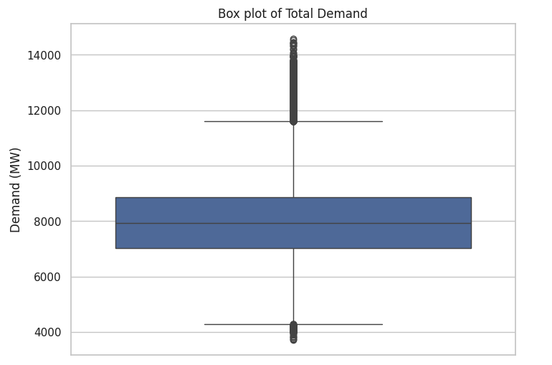The median value of electricity demand for a 30-minute interval was ~7924MW. However, as indicated by the long whiskers of the boxplot, there is a large range of values in the sample. There are also a significant number of outliers, particularly in the upper range of values.

Although descriptive analysis is useful for understanding the spread of the data, to identify patterns of demand we needed to view the data more completely, considering its time series nature.

The chart below visualises daily mean electricity demand and effectively captures the seasonality of this utility. It is evident that there are strong peaks in electricity demand during the summer and winter periods in NSW. However, there are variations in how high demand peaks across the years, for instance mean daily demand was very high in the summer of 2011, but a much lower mean daily demand was observed for the summer of 2015.

The overlaid yearly mean trendline illustrates the fluctuating demand patterns spanning the past decade or so. Demand peaked in 2010, marking its highest point in the past 14 years, only to taper off until 2015. There was a slight uptick in electricity demand from 2015 to 2018, followed by a subsequent decline. By the end of 2023, demand reached its lowest levels for the time period within the scope of this analysis.

The following chart illustrates a notable trend. Over the past decade, there has been a significant increase in the monthly variation of electricity demand. Notably, there are more pronounced extremes observed during the middle of the year, which typically coincides with the winter season. There are also larger declines in demand during the off-season periods. For instance, the difference between mean daily demand in the highest month and demand in the lowest month of 2022 was 1840MW. Comparatively, the difference between the highest and lowest months of 2013 was 1102MW, a difference of ~50%.

This pattern suggests a shifting dynamic in energy demand patterns, possibly influenced by factors such as weather fluctuations, economic conditions, adoption of renewables and subsequent changes in heavy industry practices. The Australian Research Council reports that in terms of climate, the region will continue to face more intense extremes in the future, including periods of extreme heat and others of extreme cold (https://climateextremes.org.au/stateof2022/). These climate factors may have influenced the more dramatic variations in electricity demand that are being noted in the data across the last couple of years.

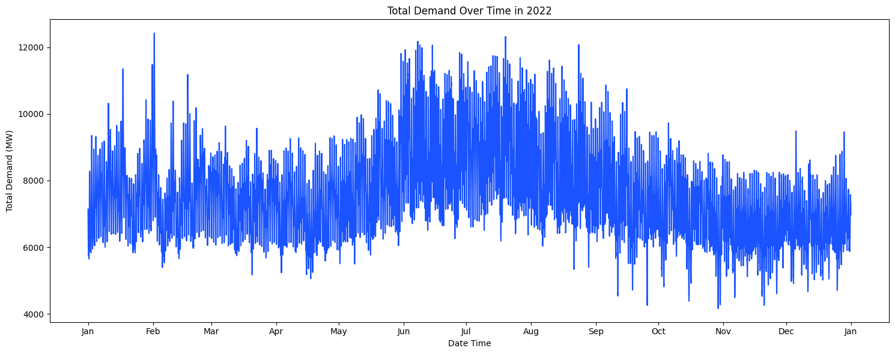A further examination of seasonal trends in electricity demand across a one-year sample reveals the heightened levels of demand observed in the winter months (June – August). As seen in the chart below, although there are some spikes in daily electricity demand in the early, warmer months of the year, demand values are generally contained within the 6000 to 10000MW range. However, from June to the end of August the daily mean demand is mostly within the 7000 to 11000MW range.

The quarterly plot below indicates that months at the start and end of the year (Q1 and Q4), generally exhibit a more stable demand pattern, whereas as Q2 shows a trend of increasing demand that builds to a peak at the start of winter in June. Subsequently Q3 shows a trend of declining demand from the highs of the mid-year.

In the above chart we can also see that within each month there are patterns of variation in the daily mean demand (indicated by the red line). A more granular examination of the data, this time at a week level, as in the chart below, shows that within a week there is a distinct pattern of changing demand. Weekdays have the highest mean daily electricity demand, before a sharp drop to lower levels on Saturday and an even further decline on Sunday.

This is likely caused by industrial and commercial activities, which are responsible for 42% of energy consumption in Australia, as opposed to residential usage at 11% (<https://www.soe.epa.nsw.gov.au/all-themes/human-settlement/energy-consumption#transport>). Commercial and industrial activities typically have higher electricity demand during weekdays and conduct less energy intensive operations on weekends, hence supporting the trend we see in the chart above (<https://www.nber.org/papers/w27937>).

The heatmap shows electricity demand broken down into a 24-hour period. Unsurprisingly, hourly total electricity demand in NSW is lower in the early hours of the morning, but not at zero, as many critical operations, such as hospitals, continue to consume electricity regardless of the hour of day. Electricity demand begins to increase more significantly from 6am onwards, generally reaching highest levels of demand around 3pm to 8pm.

Correlations ?

# 5. Analysis and Results

In this research, we embarked on an ambitious journey to forecast energy demand for the next decade (2024-2033), leveraging historical data spanning from 2010 to 2023, along with projections of temperature and population growth. Our exploration into this complex yet fascinating challenge led us to adopt a Linear Regression Model, a decision driven by its suitability for capturing the nuanced relationships between energy demand and our chosen predictors.

During the analytical phase, we meticulously divided our dataset into training and test sets, ensuring a chronological order to respect the temporal nature of our data and prevent any future information from inadvertently influencing our model's training. This step was crucial, allowing us to simulate a real-world scenario where future data remains unknown during the model-building process. Further refining our approach, we allocated 80% of the training set for the actual model training, reserving the remaining 20% for validation purposes. This strategy was instrumental in fine-tuning our model, aiming to enhance its predictive performance and reliability.

The outcome of our model's training phase was both enlightening and a testament to the complexity of forecasting energy demand. Our model achieved an RMSE of 208.012, an R^2 of 0.594, an MAE of 186.045, and a MAPE of 2.268%. These metrics provided us with a multifaceted understanding of our model's performance, highlighting its moderate accuracy and the challenges inherent in predicting energy demand with high precision. Particularly, the R^2 value, while indicating a reasonable fit, also suggested that a significant portion of the variability in energy demand remains unexplained, hinting at the potential influence of factors not captured by our model.

Parallel to our demand forecasting efforts, we engaged in predicting future temperatures, employing a Linear Regression analysis that yielded an intercept of -178.896 and a coefficient of 0.10011308. This coefficient means, for every one-year increase, the temperature is expected to increase by approximately 0.1001 degrees Celsius. This aspect of our study not only enriched our demand forecast with a critical environmental variable but also underscored the gradual yet undeniable impact of rising temperatures on energy consumption patterns.

Figure 1: Temperature linear model.

Reflecting on the results from our model's forecast, it is evident that the predicted energy demand for the next decade (2024-2033) follows a downward trend, with demand gradually decreasing from 7639.074 in 2024 to 7007.161 in 2033. This outcome, initially unexpected, may reflect a significant shift towards the adoption of renewable energy sources and increased energy efficiency measures. Such a trend underscores the dynamic nature of energy consumption patterns, potentially influenced by evolving technologies, changing consumer behaviours, and more stringent energy policies aimed at promoting sustainability.

The decreasing forecast of energy demand carries profound implications for energy planning and policy formulation. It suggests a possible transition in the energy sector towards more sustainable practices and technologies, highlighting the importance of incorporating renewable energy adoption rates and energy efficiency improvements into our forecasting models. This insight is invaluable for policymakers and energy companies as it signals a shift in demand that could influence future investments in energy infrastructure, the development of renewable energy projects, and the implementation of energy conservation measures.

As we ponder the future of energy demand, our findings illuminate the necessity for a more nuanced approach to energy forecasting. The observed downward trend in demand accentuates the role of renewable energy and efficiency in shaping future energy landscapes. It encourages further exploration into the factors driving this decline and the implications for energy supply, grid management, and environmental sustainability.

Despite time and scope constraints limiting further exploration, our research underscores the urgent need to update forecasting models to reflect the fast-evolving energy sector, particularly with the increasing adoption of renewable energy and efficiency improvements. This endeavor is crucial for more accurately predicting future energy demand and supporting the shift towards a sustainable and resilient energy system, even as our current project provides a foundational insight into these dynamics.

# 6. Discussion

# 7. Conclusion and Further Issues

# References

|  |  |
| --- | --- |
| [1] | S. H. Chowdhury and A. M. T. Oo, “Study on electrical energy and prospective electricity generation from renewable sources in Australia,” *Renewable and Sustainable Energy Reviews,* vol. 16, no. 9, pp. 6879-6887, 2012. |
| [2] | J. P. McCarty, “Ecological Consequences of Recent Climate Change,” *Conservation Biology,* vol. 15, no. 2, pp. 320-331, 2001. |
| [3] | N. Government, “NSW Climate and Energy Action,” 2023. [Online]. Available: https://www.energy.nsw.gov.au/nsw-plans-and-progress/major-state-projects/shift-renewables/renewable-energy-nsw . [Accessed 16 March 2024]. |
| [4] | C. f. C. H. a. Development, “Chapter 33. Conducting a Direct Action Campaign | Section 20. Advocacy Over and For the Long Term,” [Online]. Available: https://ctb.ku.edu/en/table-of-contents/advocacy/direct-action/long-term-advocacy/main. [Accessed 16 March 2024]. |
| [5] | Q. A. Al-Haija, O. Mohamed and W. A. Elhaija, “Predicting global energy demand for the next decade: A time-series model using nonlinear autoregressive neural networks,” *Energy exploration & exploitation,* vol. 41, no. 6, pp. 1884-1898, 2023. |
| [6] | I. Fatema, X. Kong and G. Fang, “Electricity demand and price forecasting model for sustainable smart grid using comprehensive long short term memory,” *International Journal of Sustainable Engineering,* vol. 14, no. 6, pp. 1714-1732, 2021. |
| [7] | J. Korstanje, “How to Select a Model For Your Time Series Prediction Task [Guide],” neptune.ai, 14 12 2021. [Online]. Available: https://neptune.ai/blog/select-model-for-time-series-prediction-task. [Accessed 20 03 2024]. |
| [8] | N. E. Benti, M. D. Chaka and A. G. Semie, “Forecasting Renewable Energy Generation withMachine Learning,” *Sustainability,* vol. 15, 2023. |
| [9] | R. J. Hyndman and G. Athanasopoulos, Forecasting : Principles and Practice, Heathmont, Vic.: Otexts, 2018. |
| [10] | T. Buckley, “More coal subsidies to extend Eraring?,” https://climateenergyfinance.org/, Sydney, 2024. |
| [11] | J. Korstanje, “How to Select a Model For Your Time Series Prediction Task [Guide],” 2023. [Online]. Available: https://neptune.ai/blog/select-model-for-time-series-prediction-task . [Accessed 16 March 2024]. |
| [12] | State of NSW; Department of Planning, Industry and Environment (DPIE), “NSW Electricity Strategy,” 2019. [Online]. Available: https://www.energy.nsw.gov.au/sites/default/files/2022-08/2019_11_NSW_ElectricityStrategyOverview.pdf. [Accessed March 2024]. |
| [13] | S. S. Panesar and W. Wang, “Electricity Demand Forecasting Using Neural Networks,” *Springer, Berlin, Heidelberg,* vol. 2690, pp. 826-834, 2003. |
| [14] | K. Nguyen and A. Berry, “Short-term regional electricity demand forecasting,” CSIRO, NSW, 2019. |
| [15] | Australian Energy Market Operator, “Forecasting Approach - Electricity Demand Forecasting Methodology,” 2023. |
| [16] | S. Fan and R. J. Hyndman, “Forecasting Electricity Demand in Australian,” *IEEE Power and Energy Society Meeting,* 2012. |
| [17] | B. Abu-Salih, P. Wongthongtham, G. Morrison, K. Coutinho, M. Al-Okaily and A. Huneiti, “Short-term renewable energy consumption and generation forecasting: A case study of Western Australia,” *Heliyon 8,* vol. 8, no. 3, 2022. |
| [18] | B. Elliston, M. Diesendorf and I. MacGill, “Simulations of scenarios with 100% renewable electricity in the Australian National Electricity Market,” *Energy Policy,* vol. 45, pp. 606-613, 2012. |
| [19] | T. Ahmad, H. Zhang and B. Yan, “A review on renewable energy and electricity requirement forecasting models for smart grid and buildings,” *Sustainable Cities and Society,* vol. 55, p. 102052, 2020. |

# Appendix

## Activities and Schedule

## Team Skill Mapping

## Individual Skill Mappings

Karunya Skills mapping

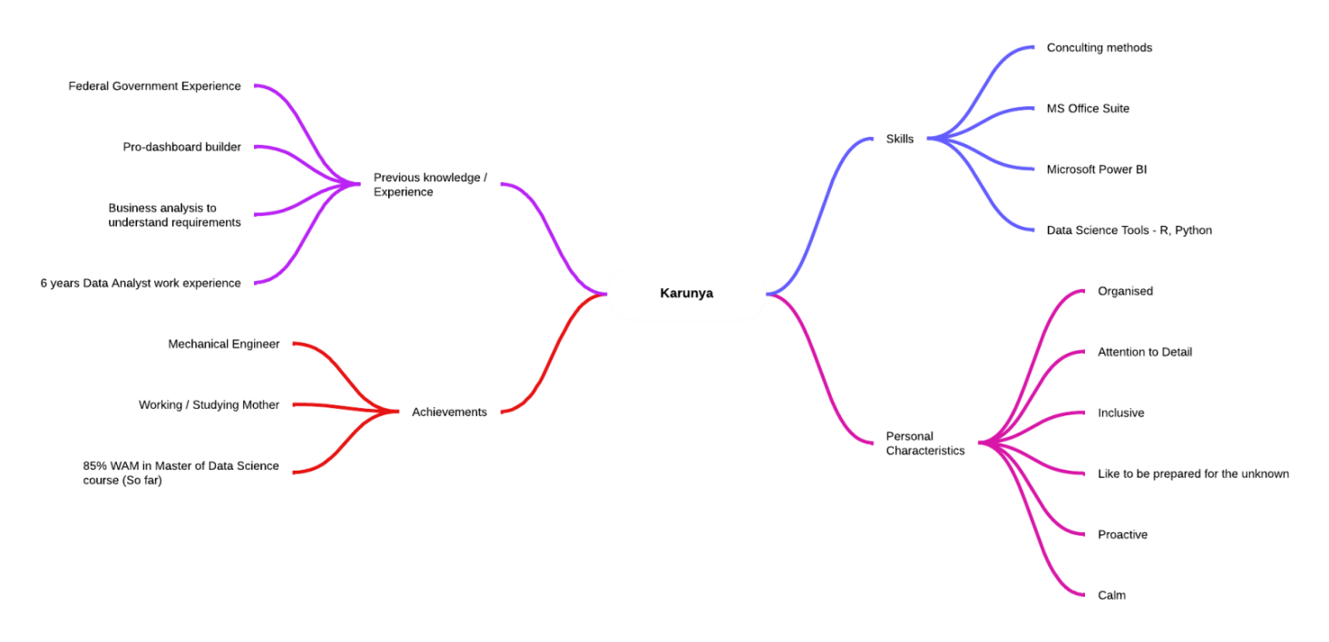

Kiara Skills mapping

Santosh Skills mapping

Mathew Fraser Skills mapping

